Animation Sheet

Standard Stand:  
Cubey moves a little bit up and down when they’re standing, indicating their activeness and the direction they are facing.  
The faced direction is presented by moving Cubey’s face roughly about one fourth of the total head width horizontally towards the faced direction.  
Cubey’s tail will be attached to the opposing direction’s edge of their head.  
Cubey’s ears may also move a little bit up and down.

Standard Walk:  
Cubey walks by moving their feet in elliptical patterns.  
One foot is always on the ground.

Standard Jump:  
The standard jump has cubey’y face move a little bit upwards, indicating they are looking upwards and the direction they are facing to.  
Cubey stretches a little, mostly shown by stretching the feet downwards and the ears horizontally towards the opposing direction.  
The tail indicates the direction of the jump by pointing into the opposing direction.

Dash:  
Cubey’s face moves again a little bit towards the direction they are dashing to.  
They will squeeze their eyes shut and open teir mouth in an excited way.  
They will be enveloped in a blue aura-like cone that indicates the kinetic energy of the dash.



Pogo Stand:  
While in pogo mode Cubey bounces on its tail and has its feet dangling from its body.

Pogo Jump:  
The animation is similar to the standard jump animation, just that the tail stiffly points downwards as long as he goes up.  
When Cubey moves downwards again it will look down and curl up its tail again.

Helicopter Standing:  
While standing Cubey stands normally, just that their tail is slowly but dynamically moving in circles above their head.

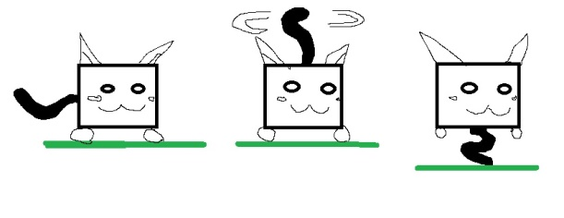- reference from character sheet

Helicopter Jumping:  
When jumping Cubey’s tail stays above their head and spins a little faster.

Helicopter Flying:  
Cubey’s tail moves rapidly like a helicopter’s blade, shown by comic-like wipe effects.  
Their feet dangle from their body and into the opposite direction they are moving towards. Cubey also faces the direction they are facing or moving towards as always.

